December 10th 2016

IRCT Council elects new Executive Committee and President

The IRCT is pleased to announce that a new Executive Committee and a new President and Vice-President were elected at yesterday’s IRCT Council meeting in Mexico City.
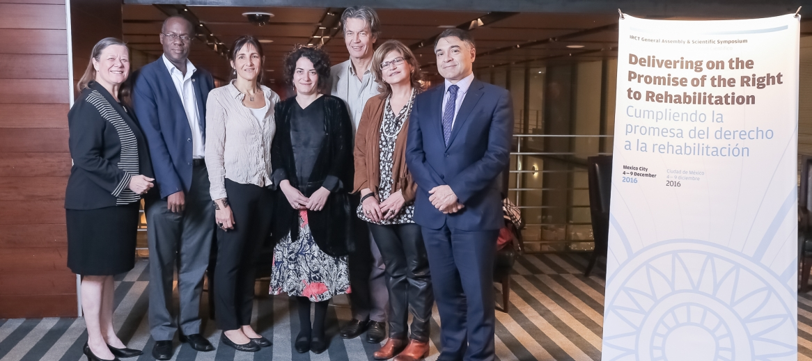
IRCT Executive Committee-from left to right; Ms. Kathi Anderson, Mr. Samuel Herbert Nsubuga, Ms. Mariana Lagos, Ms. Lela Tsiskarishvili, Mr. Michael Brune, Ms. Sana Hamzeh, Mr. Jorge Aroche
The Council unanimously elected Jorge Aroche, Chief Executive Officer of Australian IRCT member centre, Service for the Treatment and Rehabilitation of Torture and Trauma Survivors (STARTTS), as the new IRCT President. Ms Sana Hamzeh, Psychotherapist at Restart Center for Rehabilitation of Victims of Violence and Torture in Lebanon, was elected Vice-President.
“I would like to thank the IRCT Council and the General Assembly for putting their trust in me. I firmly believe that the outgoing council and not least President and Vice-President have put the organisation in an extremely strong position, which has been evident throughout the Symposium and General Assembly. Under their leadership, the global rehabilitation movement has become stronger and more united – well placed to take on any challenges facing the sector. We hope to build on this going forward and to continue the progress already made,” said Mr. Aroche.
Mr. Aroche and Ms Hamzeh will also represent their regions, Pacific and MENA respectively, and serve on the IRCT Executive Committee, with five other members from the other regions, as well as an independent expert.
Asia Executive Committee member is Pradeep Agrawal, who is the President of Indian member centre, Society for Social Research Art and Culture (SOSRAC).
Lela Tsiskarishvili, Executive Director of Georgian Center for Psychosocial and Medical Rehabilitation of Torture Victims (GCRT) was elected from the Europe region.
The elected Latin American member is Mariana Lagos, Project Coordinator of Argentine Team of Psychosocial Work and Research (EATIP).
Survivors of Torture’s Executive Director, Kathi Anderson was elected from North America.
Samuel Herbert Nsubuga, Chief Executive Officer of Ugandan member centre, African Center for Treatment and Rehabilitation of Torture Victims (ACTV) was elected as the representative of Sub-Saharan Africa.
Finally, Michael Brune from Haveno – Psychotherapie und Interkulturelle Kommunikation in Germany was elected Independent Expert to the Executive Committee.
The IRCT is governed by its membership, rooted in its democratic and regional structure. All members are invited to engage in the policy discussions at the General Assembly and to elect their representatives to the Council, who in turn elects the Executive Committee, that will guide and oversee the work of the IRCT over the next strategic period.
The IRCT would like to congratulate its new Executive Committee on being elected.
“It is an extraordinary opportunity to start the next strategic period with such a strong and committed Executive Committee. The appointed officers are an extraordinary blend of competencies, cultures and skills, and share the vision of a rehabilitation movement that works for the benefit of torture victims,” said IRCT Secretary-General Victor Madrigal-Borloz.

